­­

Attribution Data Instructions

2025 NHS Maternity Survey

May 2025

Picker

Picker is a leading international health and social care charity. We carry out research to understand individuals’ needs and their experiences of care. We are here to:

* Influence policy and practice so that health and social care systems are always centred around people’s needs and preferences.
* Inspire the delivery of the highest quality care, developing tools and services which enable all experiences to be better understood.
* Empower those working in health and social care to improve experiences by effectively measuring, and acting upon, people’s feedback.

© Picker 2025

Published by and available from:

Picker Institute Europe

Suite 6, Fountain House,

1200 Parkway Court,

John Smith Drive,

Oxford OX4 2JY

Tel: 01865 208100

Email: [Info@PickerEurope.ac.uk](mailto:Info@PickerEurope.ac.uk)

Website: [picker.org](http://www.picker.org)

Registered Charity in England and Wales: 1081688

Registered Charity in Scotland: SC045048

Company Limited by Registered Guarantee No 3908160

Picker Institute Europe has UKAS accredited certification for ISO20252:2019 (GB08/74322) via SGS and ISO27001:2022 ((certificate number 23715) via Alcumus ISOQAR. We comply with Data Protection Laws including the General Data Protection Regulation, the Data Protection Act 2018 and the Market Research Society's (MRS) Code of Conduct.

Contents

1. About these instructions 4

2. Check you have the final version of your sample file 5

3. Download the Attribution Data Spreadsheet 6

4. Find out if you have electronic records for determining antenatal or postnatal care 7

Do you have appropriate antenatal records? 7

Do you have appropriate postnatal records? 7

5. Providing attribution data using electronic records 8

Antenatal care 8

Postnatal care 8

6. Providing attribution data using the postcode method 10

Determine which postcodes your trust provides maternity services to 10

Add your list of postcodes to the Attribution Data Spreadsheet 11

Complete the antenatal column 11

Complete the postnatal column 12

7. Checks to attribution data before submission 13

Checks to conduct before attempting to submit a file 14

8. Uploading Attribution Data 16

What happens next? 18

9. Questions? 19

1. About these instructions

These instructions detail the process for checking and submitting the **Attribution Data** for the 2025 NHS Maternity Survey using the **secure file transfer server** established for the NHS Patient Survey Programme. The purpose of this process is to identify maternity service users who received their antenatal and/or postnatal care from your trust. This information allows us to determine whether the care described in the antenatal and postnatal sections of the questionnaire refers specifically to your trust. By attributing responses to the trust in such a way, we are able to provide more scored data for benchmarking, thereby allowing trusts to use the results to improve services across the whole maternity pathway.

These instructions are designed to be used by trusts delivering the survey in partnership with an approved contractor and trusts delivering the survey in-house.

Efforts have been made to ensure that the information provided is reasonably comprehensive. It is, however, necessary to supplement this handbook with a small number of complementary documents. These are:

* [**The Attribution Data Spreadsheet**](https://nhssurveys.org/wp-content/surveys/04-maternity/03-instructions-guidance/2025/MAT25_Attribution%20data%20spreadsheet.xlsx)**:** This is the template that should be used to submit attribution data regarding antenatal check-ups and postnatal care.
* [**The Survey Handbook**](https://nhssurveys.org/wp-content/surveys/04-maternity/03-instructions-guidance/2025/MAT25_Survey%20handbook.docx)**:** Which contains detailed information about the processes for preparing for and running the survey.
* [**The Sampling Instructions**](https://nhssurveys.org/wp-content/surveys/04-maternity/03-instructions-guidance/2025/MAT25_Sampling%20instructions.docx)**:** Which contains detailed information about the drawing and submitting of samples.

The most recent versions of these documents can be downloaded from the NHS surveys Website: <https://nhssurveys.org/surveys/survey/04-maternity/>.

**IMPORTANT! Please remember that no service user contact details should ever be shared with the Survey Coordination Centre - this would be a breach of the Section 251approval.**

If you have any queries about the contents of these instructions, please contact the Survey Coordination Centre (SCC) at Picker at: maternity@surveycoordination.com.

2. Check you have the final version of your sample file



During this exercise, you will be entering your Trust code, the Patient Record Numbers (PRNs) and possibly the postcode data (if using the postcode method) from your sample into the Attribution Data Spreadsheet. Before you start, contact your contractor, if you are using one, to check that you have the final, approved version of your sample file. **This is very important.**

If you are using a contractor, they may correct small errors in your sample file after you submit it to them. Therefore, you may not have the most up-to-date version of your file. Please ask them to transfer it to you if possible.

If you are doing the survey in-house, please double check you are using the version that was approved by the SCC, and not a version where people have been removed from the sample or an earlier version.

You need to have the final version of your sample file because the SCC checks your attribution data against your final sample file to make sure all of the records match up. During data analysis, we merge your attribution data with your sample data, and we need to be completely sure we are assigning the correct antenatal and postnatal information to the correct maternity service users.

In previous years, several trusts did not use the final version of their sample data when completing the Attribution Data Spreadsheet. This meant that there were extra cases included, or missing cases excluded. As a result, the SCC had to send queries to these trusts, which slowed down the approval process and created more work for the trusts involved.

3. Download the Attribution Data Spreadsheet

Download the Attribution Data Spreadsheet (available from <https://nhssurveys.org/surveys/survey/04-maternity/>) and save it as NHStrustcode_Maternity2025_AD.

Now, copy your Trust code, Patient Record Number and Postcode variables (if using the postcode method) from the final version of your sample data into the third tab of the spreadsheet (labelled ‘Data’).

**DO NOT enter any identifiable data** (i.e. names, NHS numbers, addresses) **into the Attribution Data Spreadsheet**.Postcodes can be added where needed during the compilation process but **the postcode columns (C and D) in the ‘Data’ tab, and the ‘Postcode Boundary’ tab need to be deleted before submission to SCC**.

4. Find out if you have electronic records for determining antenatal or postnatal care

Wherever possible, information from your electronic records should be used to complete the Attribution Data Spreadsheet. To determine whether you have appropriate electronic records, please make sure you understand **what we mean by antenatal and postnatal care**.

Do you have appropriate antenatal records?

Check whether you have an electronic record of whether or not each maternity service user in your sample received their **antenatal check-ups** from your trust.

This means whether your trust employed the midwife/midwives that saw a service user during their pregnancy for **appointments checking the progress of their pregnancy**, usually including checking blood pressure and urine. In many cases these check-ups would have taken place in the community, although for some (particularly higher risk) pregnancies, they may have taken place at the hospital and/or by a doctor rather than a midwife.

If the antenatal care your trust provided to a service user related to visits to the hospital for scans or blood tests only, and they received their antenatal check-ups from a different trust, **this means your trust did not provide their antenatal care** for the purposes of this exercise.

Do you have appropriate postnatal records?

Check whether you have an electronic record of whether or not each maternity service user in your sample received their **postnatal care in the community** from your trust.

This means whether your trust employed the midwife/midwives that provided postnatal care to a maternity service user **at home/in a clinic** in the first six weeks after the birth.

5. Providing attribution data using electronic records



If you do not have appropriate electronic antenatal or postnatal records for **ANY** of the service users in your sample, skip ahead to Section 6.

If you have electronic records for antenatal and/or postnatal care fitting requirements in Section 4 for **at least some** service users, complete this section.

Antenatal care

Using your electronic records of antenatal check-ups, fill in Column **E** of the ‘**Data**’ tab within the Attribution Data Spreadsheet *(‘Antenatal check-ups provided by your trust?’*), using the codes below. Please note you will need to refer to your trust’s ‘booking information’ to help you with this.

* Enter 1 for maternity service users who did receive their antenatal check-ups from your trust AND were booked in to deliver at your trust before week 25 of their pregnancy.
* Enter 0 for maternity service users who either:
  + **did not** receive their antenatal check-ups from your trust.
  + received **some** of their antenatal check-ups from your trust BUT were not booked in to deliver at your trust until **25 weeks pregnant or later**.

Postnatal care

Using your electronic records of postnatal care in the community, fill in Column **F** of the ‘**Data**’ tab within the Attribution Data Spreadsheet *(‘Postnatal care in the community provided by your trust?’*), using the codes below. Please note you will need to check the service user’s address details to see if they moved address within six weeks of giving birth.

* Enter 1 for maternity service users who did receive their postnatal care in the community from your trust.
* Enter 0 for maternity service users who either:
  + **did not** receive their postnatal care in the community from your trust.
  + received **some** of their postnatal care in the community from your trust, BUT you are aware that they **moved to a different trust within six weeks of giving birth**.



**What’s next?**

Where you have used the electronic method to provide details on antenatal AND postnatal care, enter code 1 in Column **G** of the ‘**Data**’ tab in the Attribution Data Spreadsheet (“*Which method did you use for this attribution exercise?”*).

If some maternity service users are missing a value at Column E and/or F, carry on to Section 6 to fill in any gaps using the postcode method.

If you have now filled in Columns E and F for **EVERYONE** in your sample, **delete the postcode columns (C and D)**, and the ‘**Postcode Boundary**’ Tab.

Skip ahead to Section 7.

6. Providing attribution data using the postcode method



If you have appropriate electronic antenatal and postnatal records for **EVERYONE** in your sample, skip ahead to Section 7. For now, you can ignore Column D (*‘Postcode match’).*

The postcode method should only be used to complete the Attribution Data Spreadsheet in cases where you do not have appropriate electronic antenatal or postnatal records for some or all maternity service users in your sample. The main steps involved in this section are listed below. The remainder of this section provides more detailed information for each of the steps below:

1. Create a list of postcodes that your trust delivers maternity services to.
2. Copy and paste this list of postcodes to the Attribution Data Spreadsheet in the ‘**Postcode Boundary**’ tab. **IMPORTANT! Make sure the format of the data exactly matches the postcode data already included in Column C in the ‘Data’ tab otherwise the formula for the ‘Postcode match’ column won’t work. For example, postcodes should be in the format ‘AB8 3YP’ and not ‘AB83YP’.**
3. Use the results automatically provided in the ‘**Postcode match**’ column (**D**) and your trust’s booking information to complete/fill in gaps in the antenatal column of the Data tab.
4. Use the results automatically provided in the ‘**Postcode match**’ column and the service user’s address details to complete/fill in gaps in the postnatal column of the ‘**Data**’ tab.
5. **IMPORTANT! Please delete the postcode columns (C and D) as well as the ‘Postcode Boundary’ tab before submitting the file to the SCC.**

If you have a more accurate method of determining who lives within the geographical area your trust provides maternity services to (for example by using CCG codes), please use this method instead and notify the SCC at maternity@surveycoordination.com that you have done so.

Determine which postcodes your trust provides maternity services to

Create a list of the postcodes that your trust has a contract to deliver maternity services to (i.e., antenatal check-ups and postnatal care in the community). If this information is not held electronically, we suggest you speak with your community midwife manager or community midwifery team as they will have knowledge of the specific geographical areas that they cover. You may also find it useful to check with your trust’s antenatal clinic manager.



**Does your trust’s boundary overlap with another trust’s?**

In some cases, trust boundaries may overlap with those of a neighbouring trust. If there are some postcodes where you are not sure whether your trust or a neighbouring trust provides antenatal or postnatal care, please **do not** include these postcodes in your list.

Add your list of postcodes to the Attribution Data Spreadsheet

Enter your list of postcodes into the fourth tab of the Attribution Data Spreadsheet (labelled ‘**Postcode Boundary**’).

The spreadsheet will now automatically match these postcodes against residential postcodes from the sample, which you should have already pasted into the second tab (labelled ‘**Data**’, column C) along with the rest of your sample information. In the ‘**Data**’ tab you will see that Column **D** (‘*Postcode match’*) has been populated with a ‘YES’ or ‘NO’ for each row. A ‘YES’ indicates that the maternity service user lives in one of the postcodes in your list, and a ‘NO’ indicates that they do not.



**Postcode format**

The list of postcodes you enter in the second tab must be in **EXACTLY** the same format as the residential postcodes in the sample, otherwise the matching formulae will not work.

If you get error messages in Column D or ‘NO’ for every case in Column D, please check your postcodes for extra spaces or other formatting differences.

**IMPORTANT! Please delete the postcode columns (C and D) as well as the ‘Postcode Boundary’ tab before submitting the file to the SCC.**

Complete the antenatal column

Fill in Column **E** of the Attribution Data Spreadsheet (‘**Data**’ sheet) (*‘Antenatal check-ups provided by your trust?’*) for each service user in your sample (**except where you have already completed this using electronic records**), using the codes below. Please note you will need to refer to your trust’s ‘booking information’ to help you with this.

* Enter 1 for maternity service users who have a ‘YES’ in Column D AND were booked in to deliver at your trust before week 25 of their pregnancy.
* Enter 0 for maternity service users who either:
  + have a ‘NO’ in Column **D**.
  + have a ‘YES’ in Column **D** BUT were not booked in to deliver at your trust until **25 weeks pregnant or later**.

Complete the postnatal column

Fill in Column **F** of the Attribution Data Spreadsheet *(‘Postnatal care in the community provided by your trust?’*) for each maternity service user in your sample (**except where you have already completed this using electronic records**), using the codes below. Please note you will need to check the service user’s address details to see if they moved address within six weeks of giving birth.

* Enter 1 for service users who have a ‘YES’ in Column D.
* Enter 0 for service users who either:
  + have a ‘NO’ in Column **D**.
  + have a ‘YES’ in Column **D** according to their postcode at the time of birth, BUT you are aware that they **moved outside of your trust’s boundary within six weeks** of giving birth.



**What’s next?**

Where you have used the postcode method to provide details on antenatal AND postnatal care, enter a code 2 in column G.

If for some maternity service users, you used the electronic method for either antenatal or postnatal care, and used the postcode method for the other users, please enter a 3 in column G.

**IMPORTANT! Please delete the postcode columns (C and D) as well as the ‘Postcode Boundary’ tab before submitting the file to the SCC.**

7. Checks to attribution data before submission

The first step of the process is to pull together the required data for the attribution data submission. For this, you will need to enter all the information relating to your attribution data in the ‘**Attribution Data Spreadsheet**’ and save this file as <NHStrustname_Maternity2025_AD>.

The table below shows an example of the populated spreadsheet for a trust using electronic records for all cases.

Page **12** of **20**

Checks to conduct before attempting to submit a file

All submissions need to undergo a number of important checks before they can be submitted onto the secure file transfer server. This will help assess whether a file matches the guidance outlined – for example, if a column should only include a 1 or 0 as valid codes, is this reflected in what is being uploaded.

For further guidance on what checks are required, please refer to the second tab ‘**Declaration form**’ in the ‘**Attribution Data Spreadsheet**’ which outlines the checks each trust must complete before submitting their attribution data.

For completeness, the checks each trust must carry out before submitting the attribution data are split into two sections and outlined below.

* The first checks should be carried out before completing the attribution data spreadsheet:
  + Make sure you have read the 2025 attribution data instructions (this document) and get in touch with the SCC if you have any queries.
  + Make sure you are using electronic records wherever possible. If you do not have electronic records for all of your attribution data and you have used an alternative to the postcode boundary method for collating this data, make sure you have notified and checked this with the SCC.
* The second set of checks should be carried out before submitting the data through the secure file transfer server:
  + Check all cases have a trust code.
  + Check you have copied the full list of PRNs from the final, signed off version of your sample into the attribution data spreadsheet.
  + Check the PRNs are in the correct format – i.e., ENNNNXXX, with XXX representing the trust code and NNNN the sample number.
  + Check the spreadsheet does not contain any duplicate PRNs.
  + Check the total number of PRNs match the original sample i.e. no mothers have been excluded since the sample was signed off by the SCC.
  + Check the cells for any mothers who have moved to another area or who have died or have been excluded since the sample was signed off by the SCC.
  + Check only codes 0 or 1 have been used for the ‘Antenatal check-ups’ column.
  + Check only codes 0 or 1 have been used for the ‘Postnatal care in the community’ column.
  + Check you have used electronic records to compile the attribution data wherever possible.
  + Check codes 1, 2, 3 or 4 have been used for the ‘attribution exercise’ column.
  + **IF USING THE POSTCODE METHOD**: Check you have copied the postcode data from the final, signed off version of your sample into the attribution data spreadsheet.
  + **IMPORTANT!** Check postcode (column **C**), postcode match (column **D**) and the ‘**Postcode Boundary**’ tab have been **removed** from the file before being uploaded. The **SCC should not receive any postcode data.**
  + Confirm no changes have been made to the column headings in the ‘**Data**’ tab.
  + Check all the necessary columns have been completed.

Finally, ahead of any attempted submission of attribution data, please check that you have fully read and adhered to the instructions outlined in this document.

8. Uploading Attribution Data

Once you are happy with the attribution data and it has been checked against the listed checks, then you can start the submission process.

**First, please check that ‘Postcode’ column (C) and ‘Postcode match’ column (D) as well as the ‘Postcode Boundary’ tab have been removed before submission to the SCC.**

To upload the file to the FTP, please follow these steps:

* **Step 1:** Open your browser window (e.g. Google Chrome, Microsoft Edge, Firefox etc.).
* **Step 2:** Enter <https://coordinationftp.nhssurveys.org/app> in the URL textbox.
* **Step 3:** A login page will open. Enter the username/password which will be provided to you by the SCC:
  + Username: [xxxx@xxxxxx.nhs.uk](mailto:xxxx@xxxxxx.nhs.uk)
  + A screenshot of a login box

    Description automatically generatedPassword: xxxxxx2025
* A screen shot of a video chat

  Description automatically generated**Step 4**: You have the option to watch a short video demonstrating how to use the system. If you don’t want to watch the video, click the ‘Proceed’ button.

* 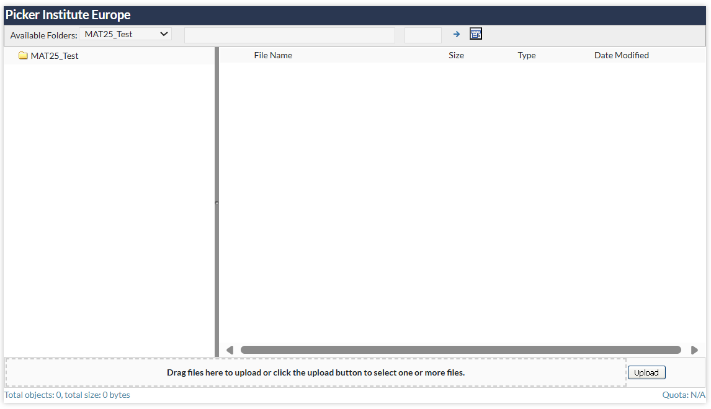**Step 5**: You will be directed to the Welcome page where you will find the Picker Institute window. Please click the upload button to select your file OR drag your file onto the text saying, ‘**Drag files here to upload or click the upload button to select one or more files**.’.

* 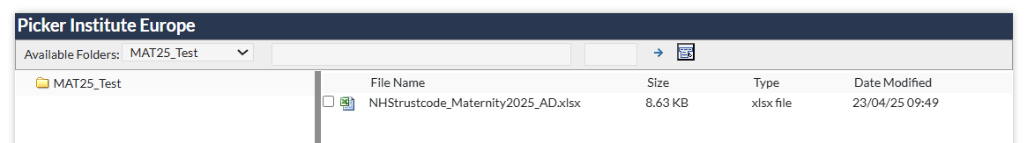**Step 6**: When your file is uploaded it will appear into the right-hand side area of the window under ‘File name’.



Please note, the login has been linked to your trust for security purposes. As a result, if you get locked out of your account or require the password to be changed, you must get in touch with  [maternity@surveycoordination.com.](mailto:maternity@surveycoordination.com)

What happens next?

Once the SCC receives an attribution data file they will conduct some further checks and may well have additional queries with regards to your submission. If so, these will be raised via email to the nominated contact for the trust. This may require amendments to be made to the file and a revised version uploaded. Once the SCC are happy with the submitted data, they will confirm sign-off.

If you spot any issues such as errors or typos in your file after submitting the attribution data, please let the SCC know as soon as possible. You will not be able to upload another version until your original submission has been rejected.

9. Questions?

For any questions, please contact the Survey Coordination Centre (SCC) based at Picker at  [maternity@surveycoordination.com.](mailto:maternity@surveycoordination.com)

Picker Institute Europe  
Suite 6, Fountain House,

1200 Parkway Court,

John Smith Drive,

Oxford OX4 2JY

Tel: +44 (0) 1865 208100

info@pickereurope.ac.uk

picker.org

Charity registered in England and Wales: 1081688

Charity registered in Scotland: SC045048

Company limited by guarantee registered in England and Wales: 3908160